Sun | Mon | Tue | Wed | Thu | Fri | Sat
 |  |  |  | 1  Bingo 7 p.m.  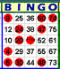 | 2  Dinner 6-8 p.m.  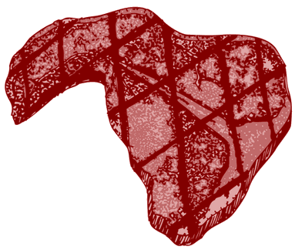  Steak Night | 3
4  Breakfast 9-12:30   | 5 | 6 | 7 | 8  Bingo 7 p.m. | 9    Dinner 6-8 p.m. | 10    Music with Freddie  8:00 p.m.-12:00 a.m.
11  Breakfast 9-12:30    McGuire Hosp Visit | 12  Legion General Membership Meeting  7:00 p.m.  Election of Corporation Officers | 13  Auxiliary General  Membership Meeting  7:00 p.m. | 14  SAL General Membership Meeting  7:00 p.m. | 15  Bingo 7 p.m. | 16  Dinner 6-8 p.m. | 17  House Committee Meeting, 10:00 a.m.
18  Breakfast 9-12:30  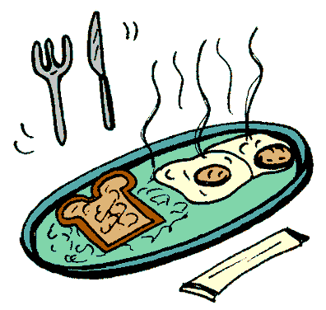 | 19  DAV - 7:00 p.m. | 20 | 21  Executive Committee Meeting, 7:00 p.m. | 22  Bingo 7 p.m. | 23  Dinner 6-8 p.m. | 24
25  Breakfast 9-12:30  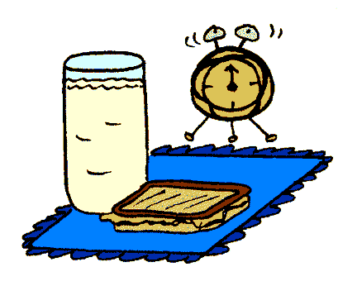 | 26 | 27  40/8 – LaFemme | 28 | 29  Bingo 7 p.m. | 30  Dinner 6-8 p.m. | 31
Races when scheduled on the “Big Screen” | Legion Appreciation Hour  Monday-Friday  4:00 – 7:00 p.m. |  |  |  | The menu for Friday evening meals can be obtained by calling the Clubroom at:  732-1425

August
2002

